Project Design Phase-II Technology Stack (Architecture & Stack)

|  |  |
| --- | --- |
| Date | 17 October 2022 |
| Team ID | PNT2022TMID17537 |
| Project Name | Project - A Gesture- based tool for sterile  browsing of Radiology Images |

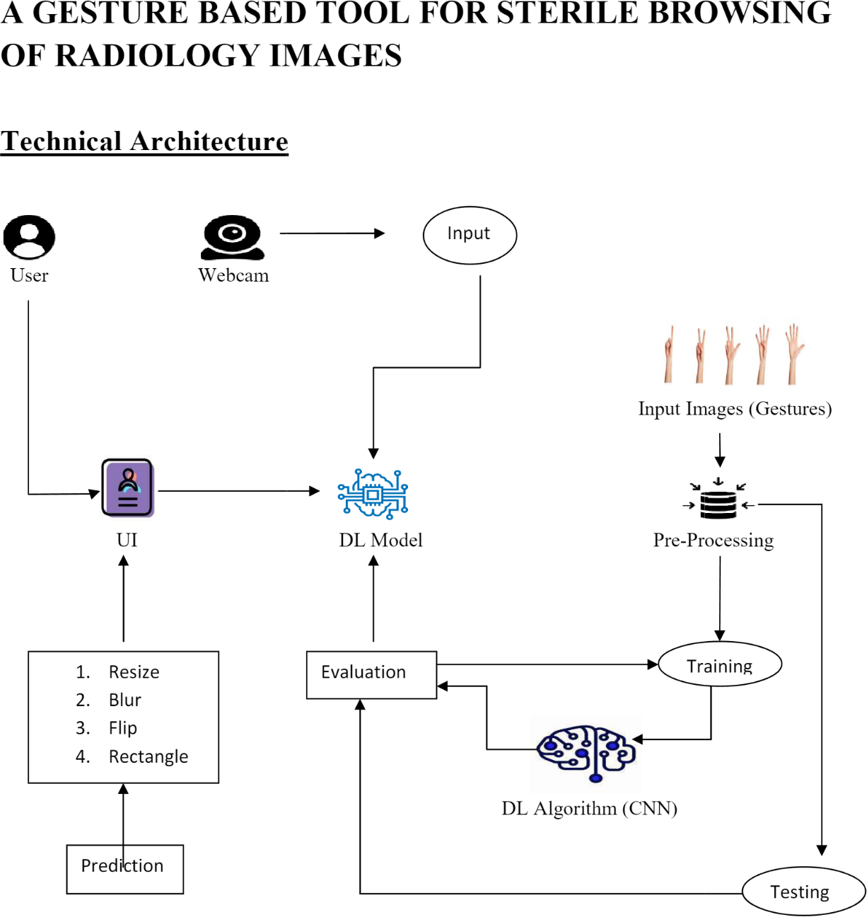

Table-1 : Components & Technologies:

|  |  |  |  |
| --- | --- | --- | --- |
| **S.No** | **Component** | **Description** | **Technology** |
| 1. | User Interface | How user interacts with application e.g. Web UI.. | HTML, CSS, JavaScript. |
| 2. | Application Logic-1 | Upload image in an application | Python |
| 3. | Cloud Database | Database Service on Cloud | IBM DB2, IBM Cloudant etc. |
| 4. | Machine Learning Model | Purpose of Machine Learning Model | Object Recognition Model, etc. |
| 5. | Infrastructure (Server / Cloud) | Application Deployment on Local System / Cloud Local Server Configuration:  Cloud Server Configuration : | Local, Cloud Foundry, Kubernetes, etc. |
| 6. | Convolutional Neural Network | Initialize the model | CNN Layer |

Table-2: Application Characteristics:

|  |  |  |  |
| --- | --- | --- | --- |
| **S.No** | **Characteristics** | **Description** | **Technology** |
| 1. | Open-Source Frameworks | List the open-source frameworks used | Technology of Open source framework |
| 2. | Scalable Architecture | Justify the scalability of architecture (3 – tier, Micro-services) | Technology used |
| 3. | Availability | Justify the availability of application (e.g. use of  load balancers, distributed servers etc.) | Technology used |
| 4. | Performance | The system responds to the user in a second and the hardware and software works well | Technology used |